All solver
All Solver TCR Christmas challenge event

Presented by Lylera
Prove of Concept solver challenge

Forensic - Happuru Kurismasu
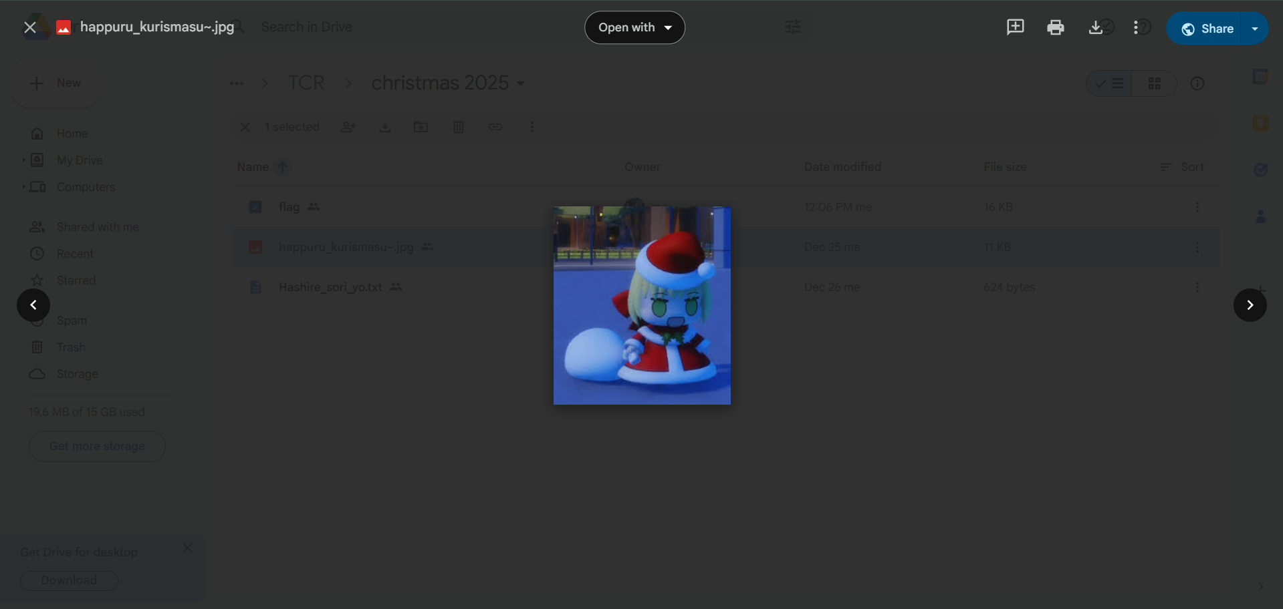
So here is the first challenge. Padoru image. Nothing special. Lets download it

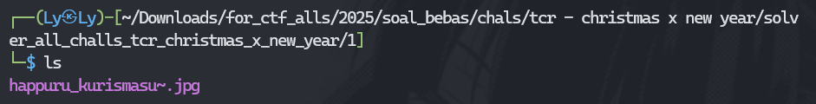

And then how? Let's use something that can reveal what is inside the image data. Strings might helpful for this case

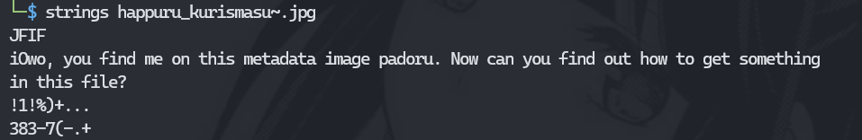
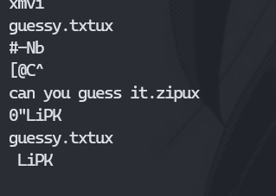
As you can see, there are 2 files. If we check using “exiftool”, you can see the metadata of the image
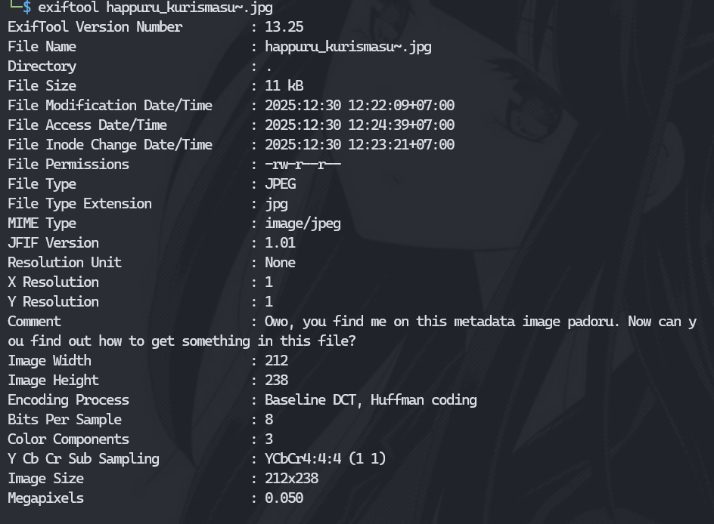
So the comments say “file”, but how to get the file inside the image? You can use this one https://www.kali.org/tools/binwalk/ documentation to see and getting the file inside of the image. Lets use it :
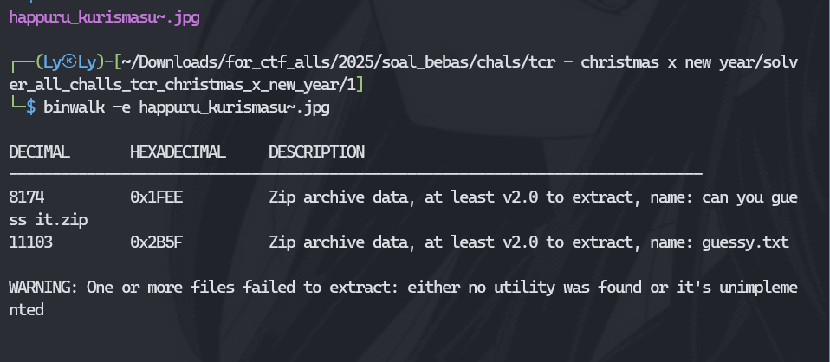
Done. and then lets see what is this folder:
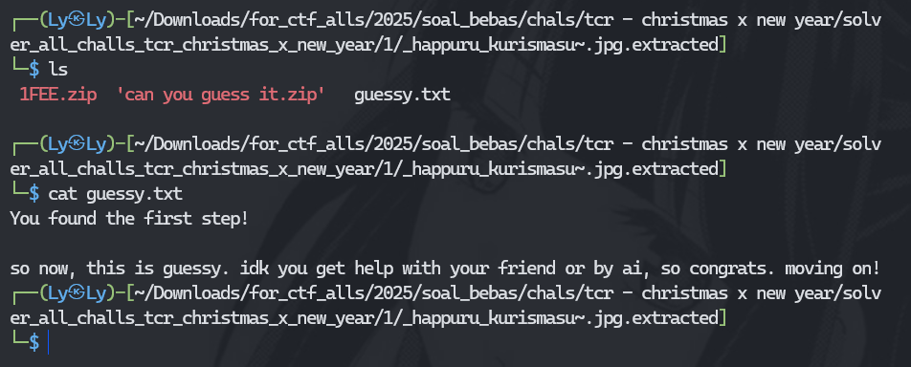
So there are 2 zip files and 1 txt. Maybe txt referrer to ‘can you guess it.zip’? Lets unzip it
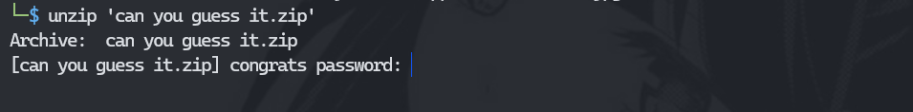
So you need a password to crack it. Welp you can use fcrackzip like this:
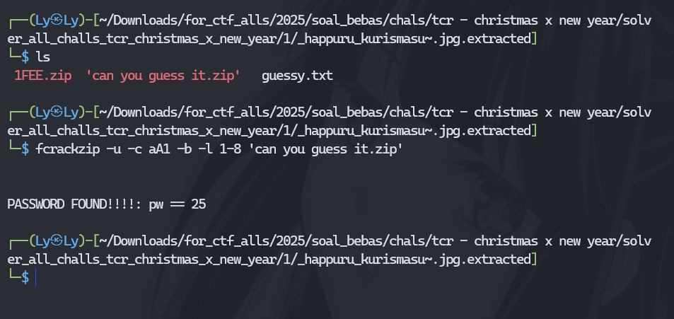
Explanation: “https://www.kali.org/tools/fcrackzip/”. And then open up the pw and we get the file name “congrats”. Here are the steps:
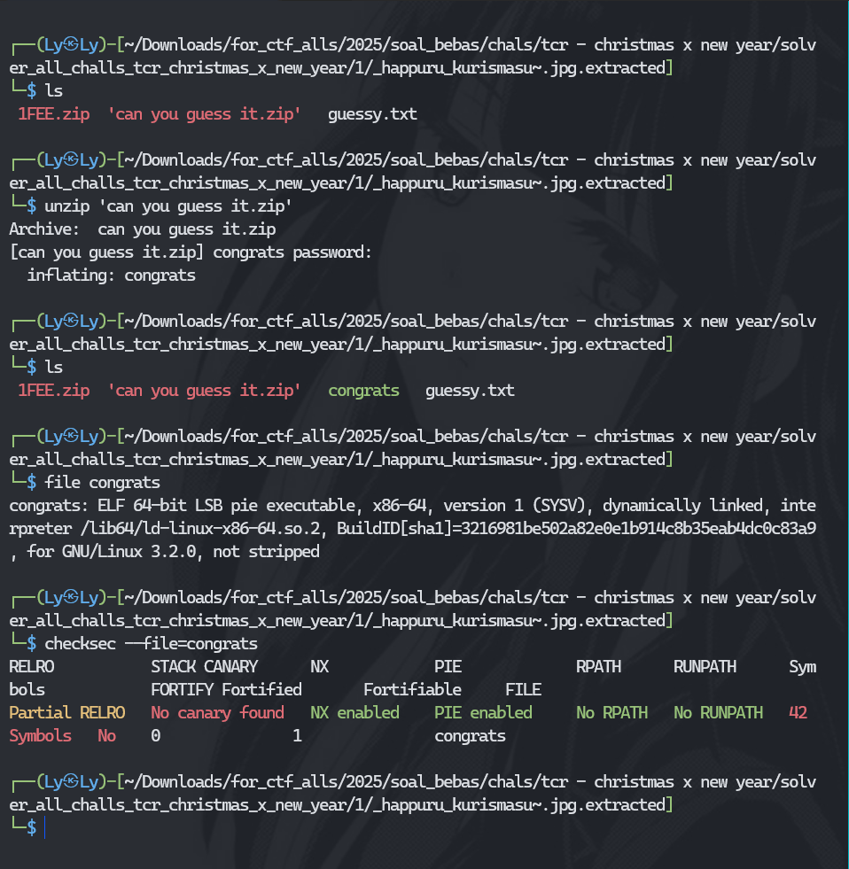
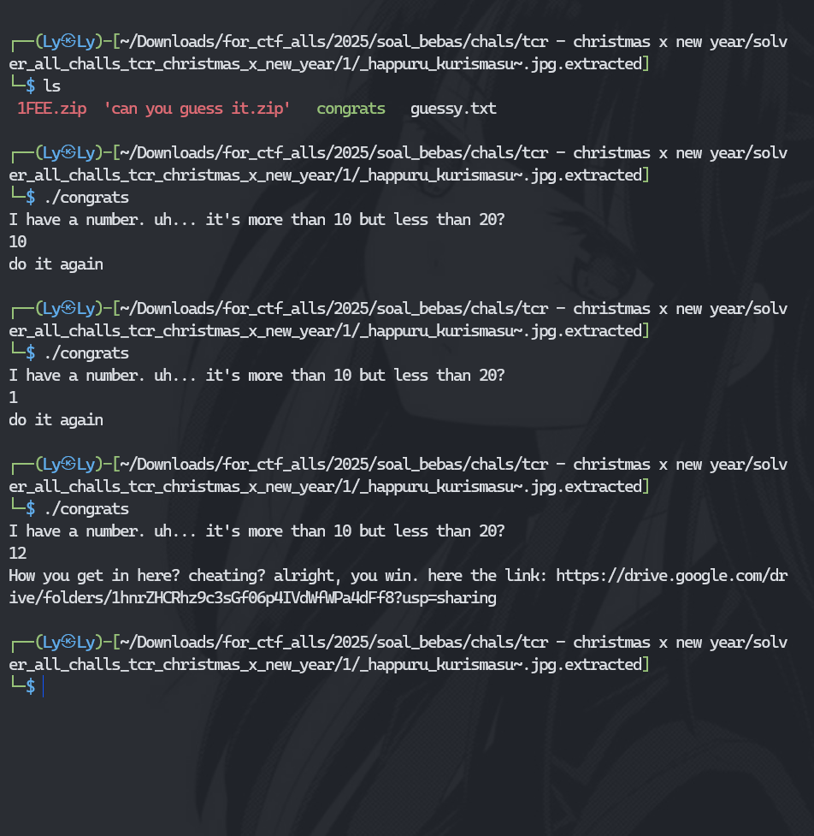
So it will ask you about numbers. It is very guessy here but you can brute it from 10 to 20 and which one is correct. But this is the intended way. What if unintended? You can do “strings congrats” and it will get the link. Here:
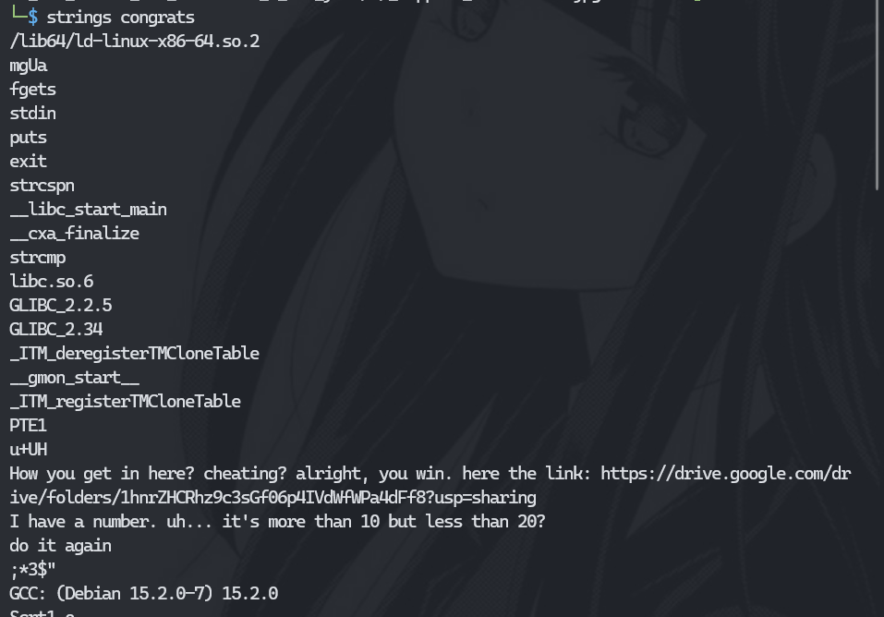
But the problem is, you will never get the clue. So yeah…, lets go to the final link:
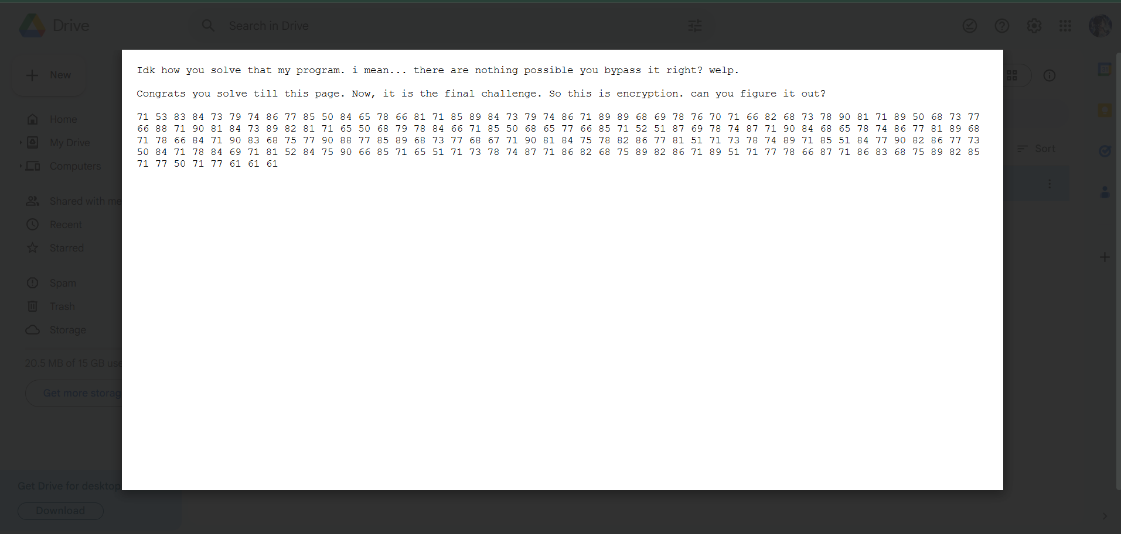
So we must decrypt this text into the real one. It seem like decimal, but lets try it:
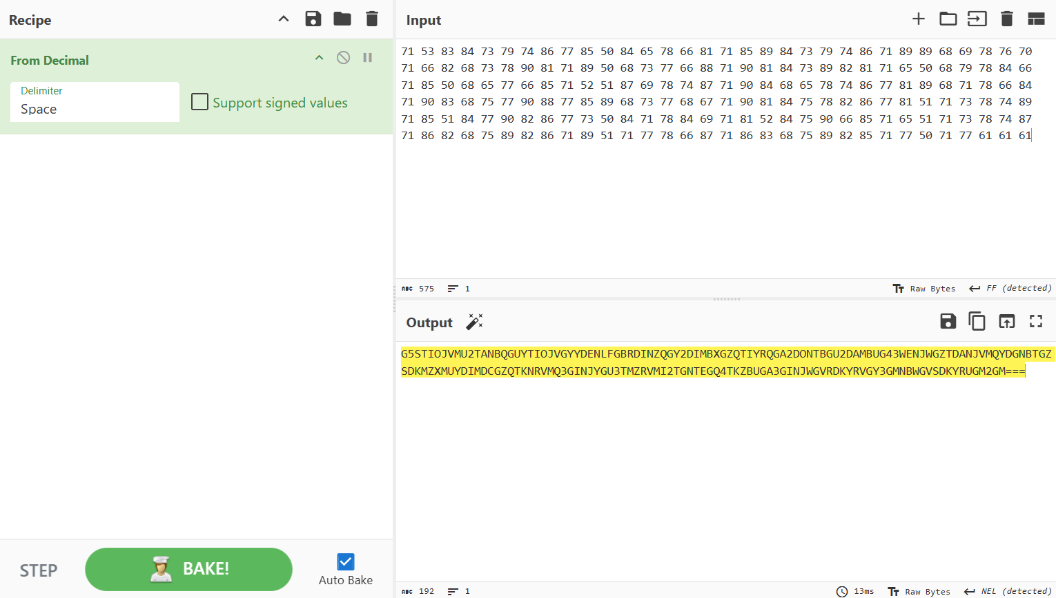
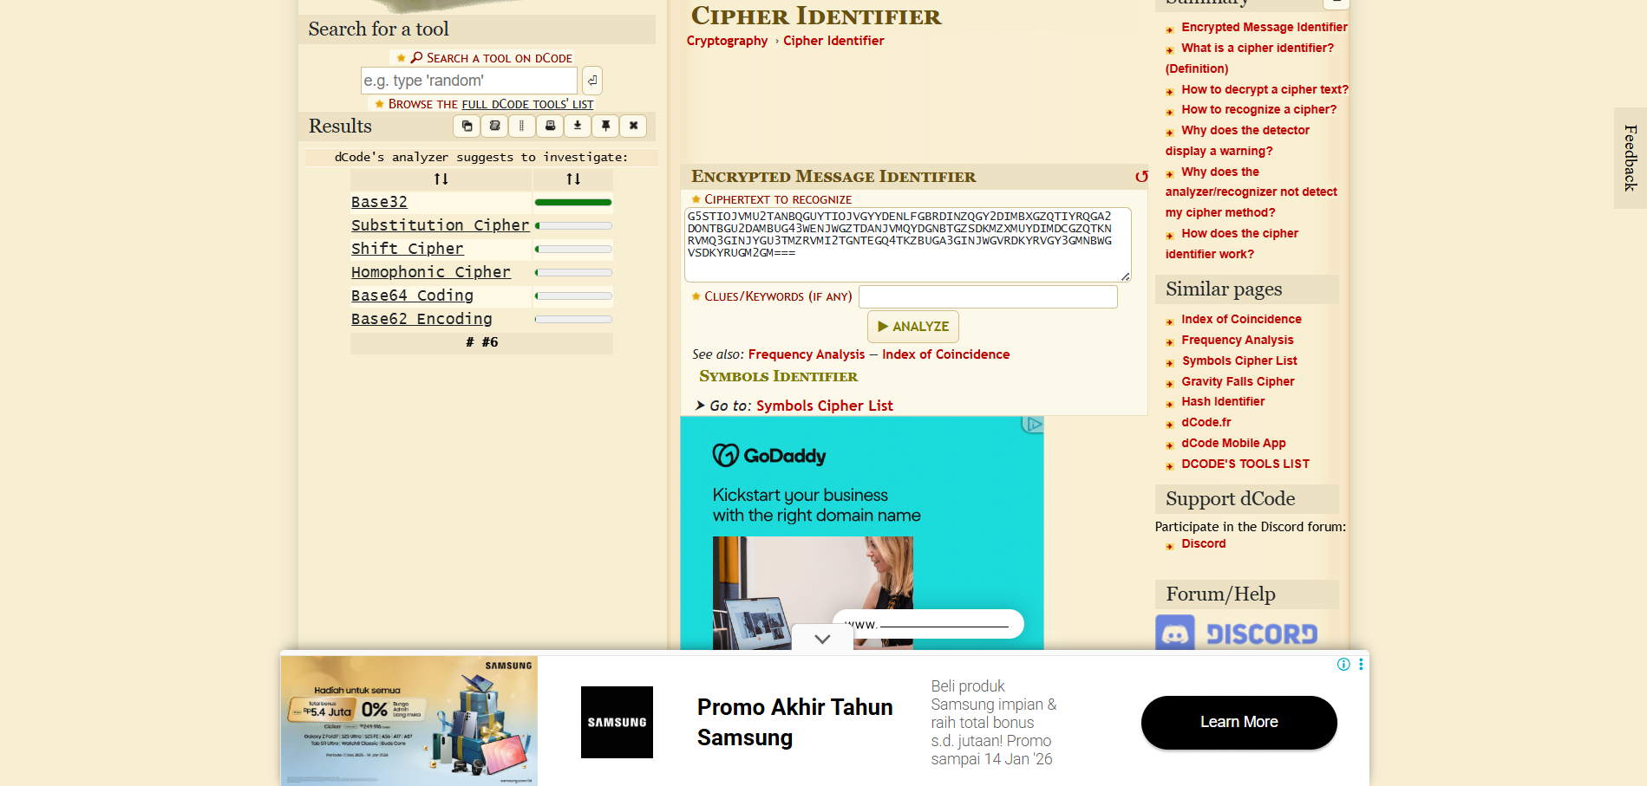
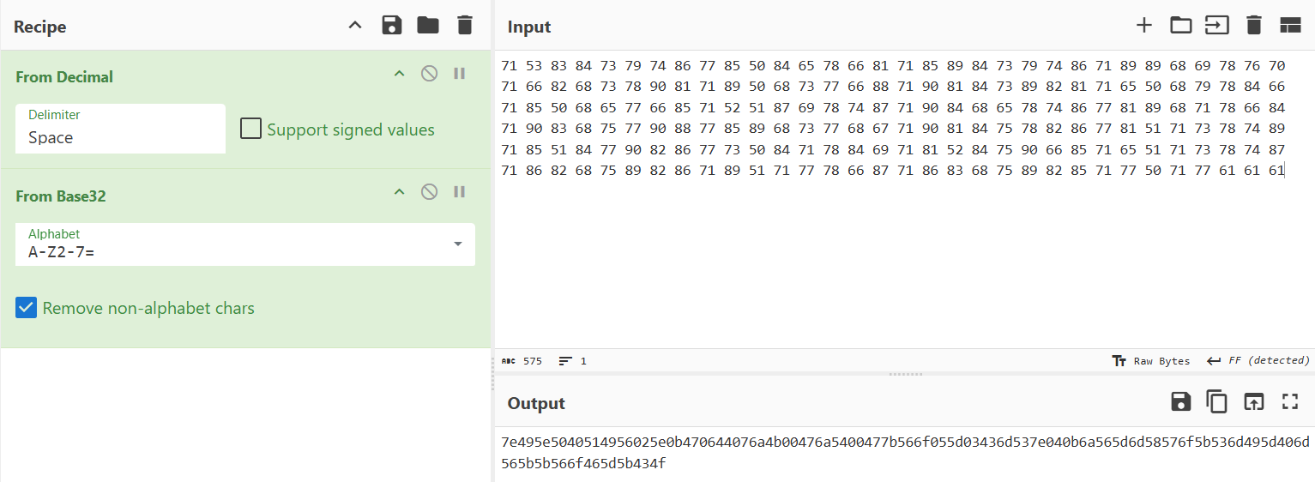
And lastly, it should be hex right? Welp no. it is xor. But we don’t have a key. You can ask the gpt to solve it
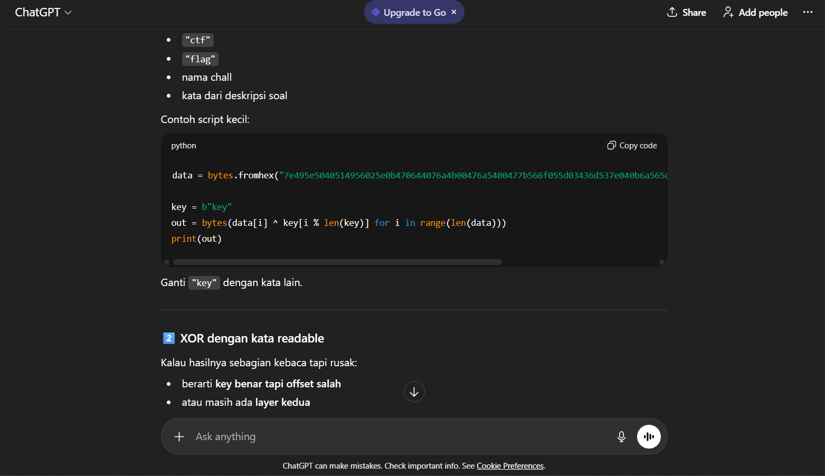 lets try it. But remember, how you get the flag if you don’t know the key?
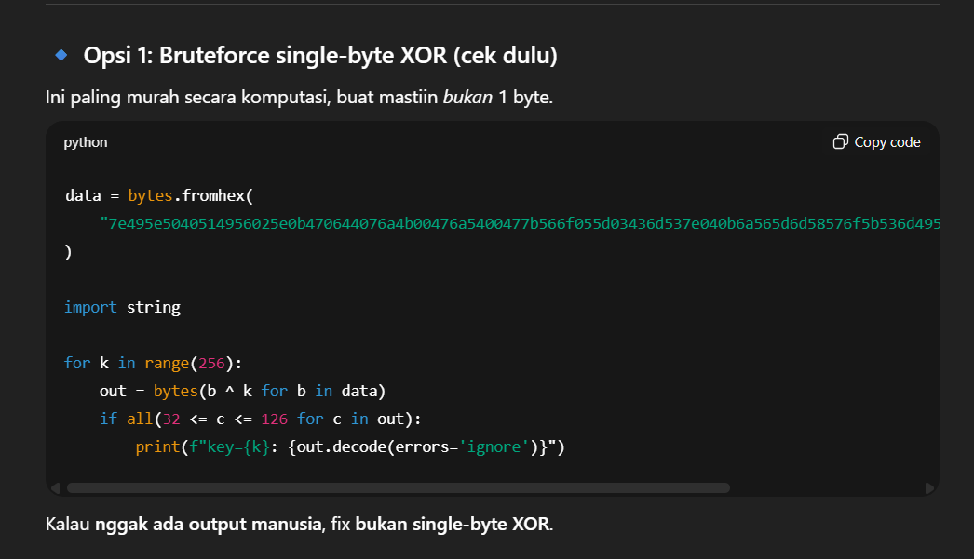
The result:
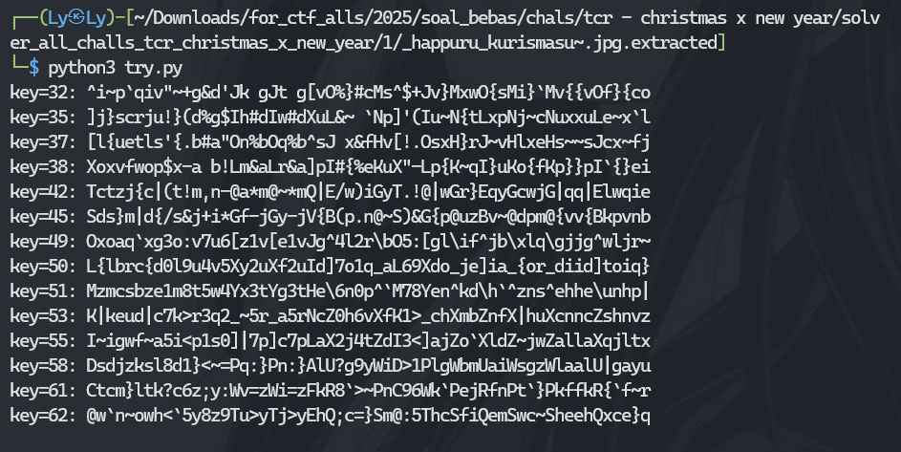
But if you look it up before (“12”, “25”) and the name file “happuru_kurismasu” which means it is christmas now. So given this combination, you will get flag and key = “2025”. So here the result:

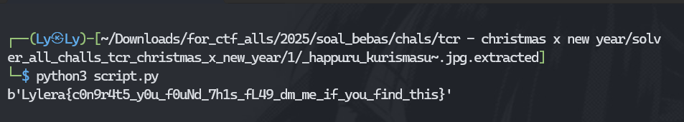

Flag: Lylera{c0n9r4t5_y0u_f0uNd_7h1s_fL49_dm_me_if_you_find_this}

Crypto - Hashire Sori yo
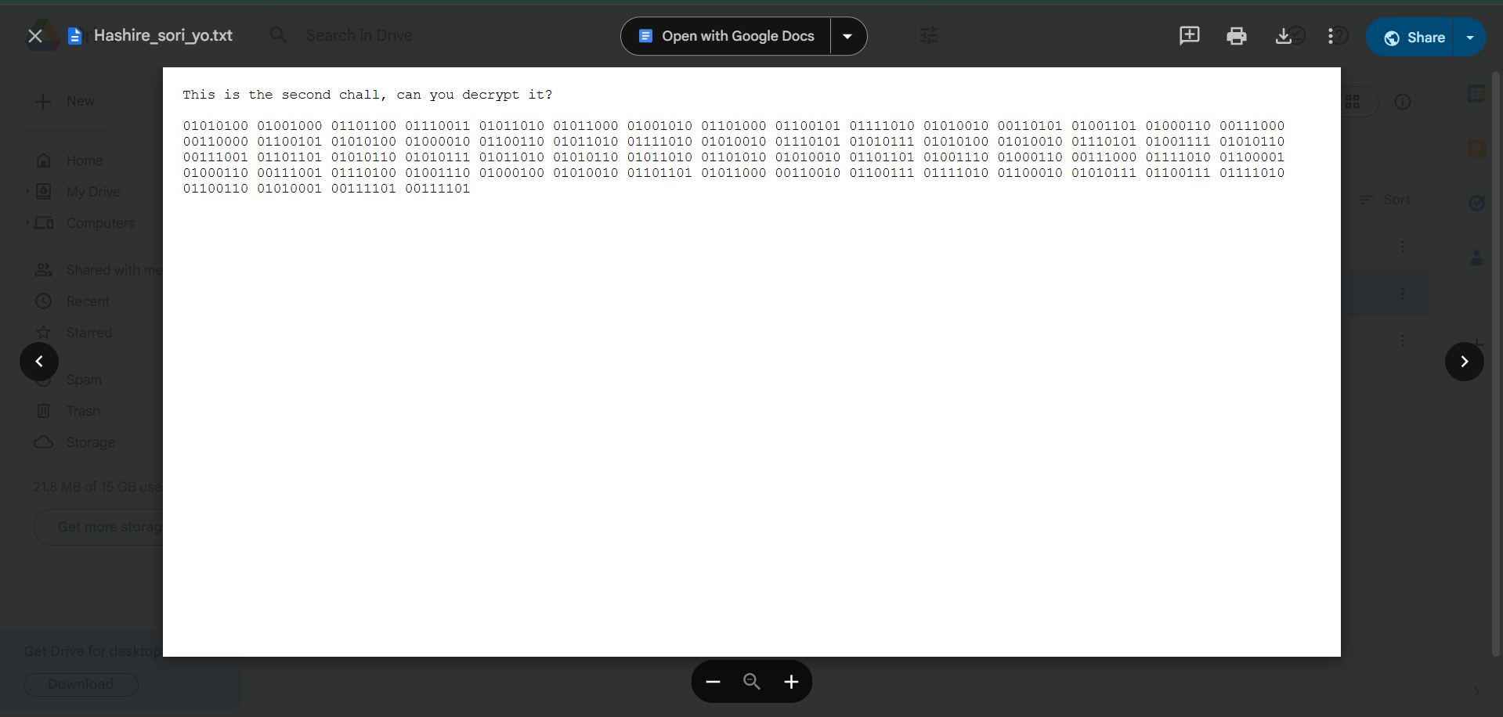
Given text with binary encode. So lets decode it:
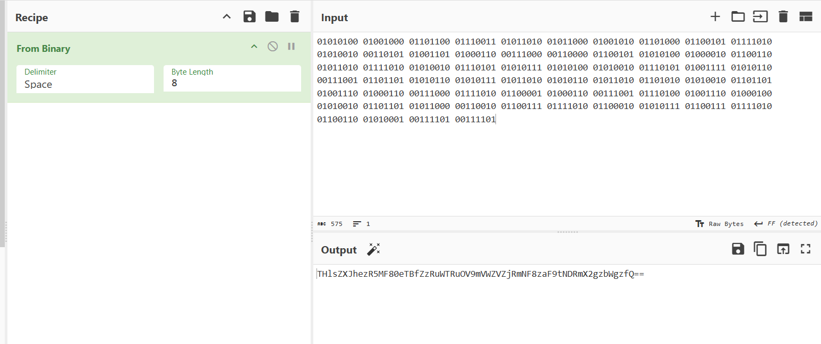
And then use cipher identifier to know it
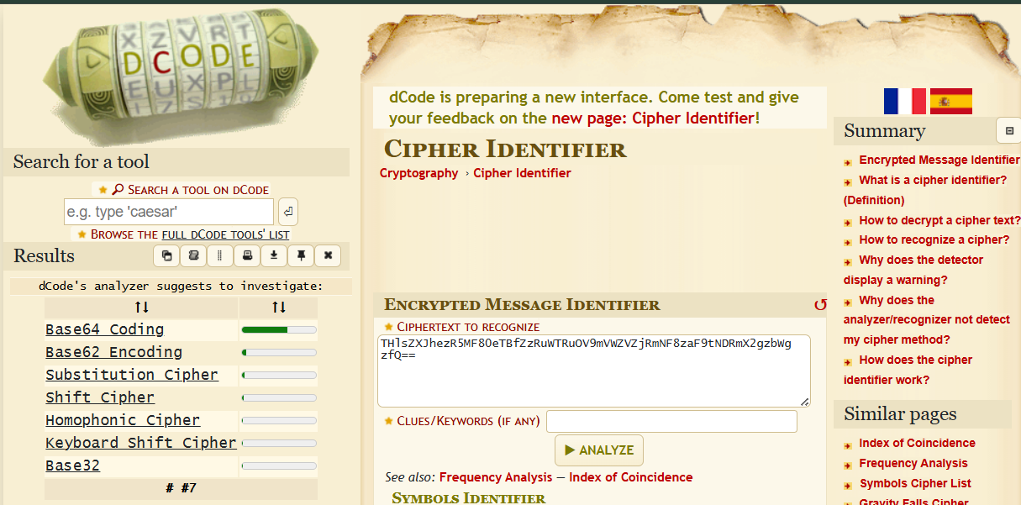
And here the last:
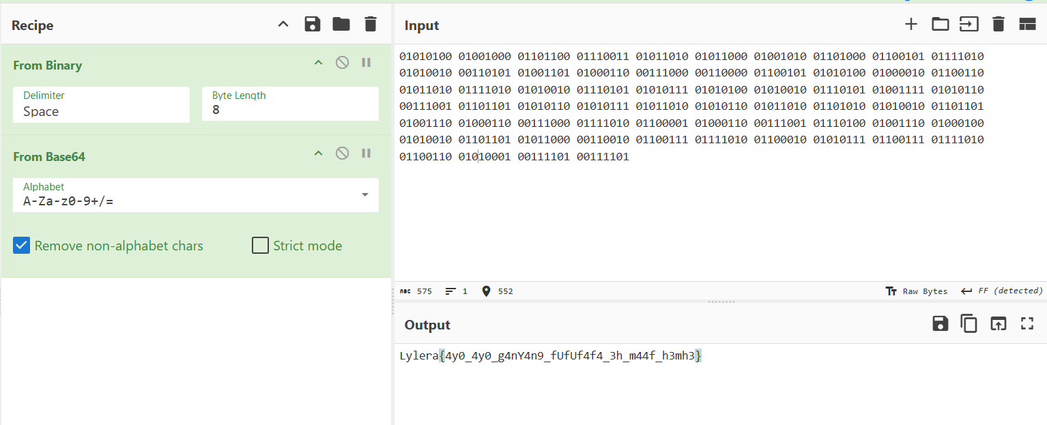
Very easy right?

Flag: Lylera{4y0_4y0_g4nY4n9_fUfUf4f4_3h_m44f_h3mh3}

Pwn - Padoru_padoru~

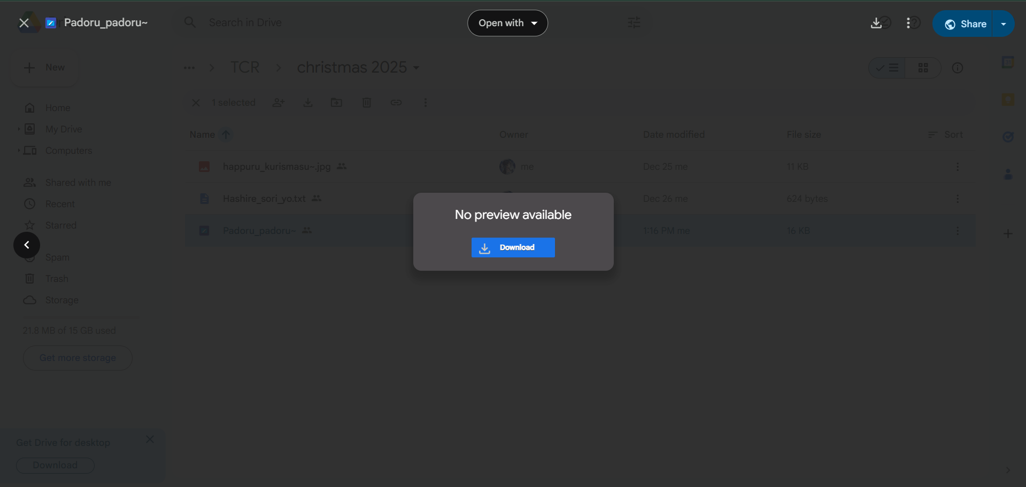
Lets download it
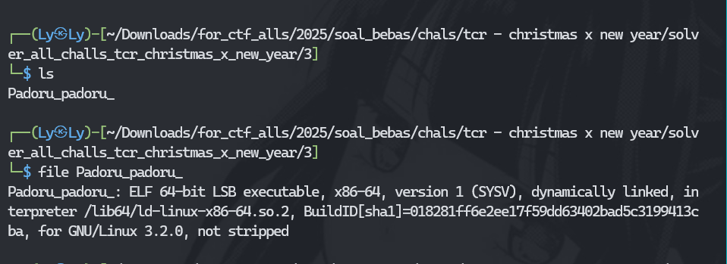
Alright lets run it. Hoping got the flag right?
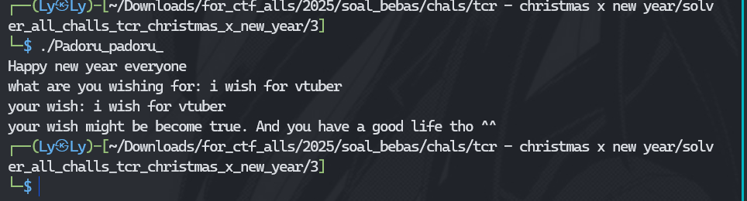
Welp. Where is the flag? Lets try to use strings:
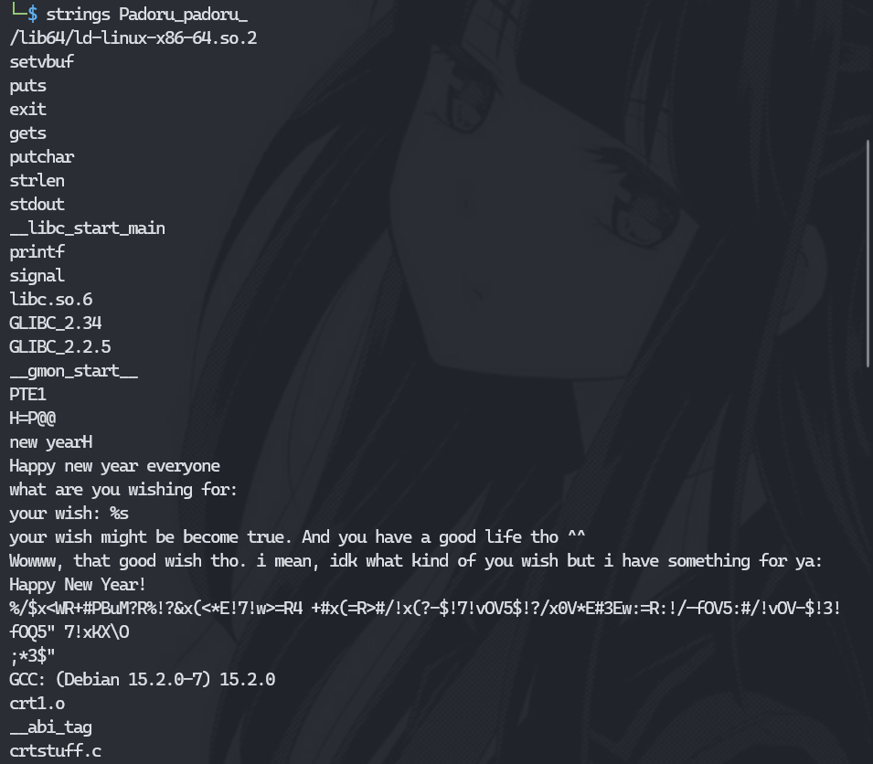
So there are other sentences. Huh… How to trigger it? This is binary exploitation. Welcome~
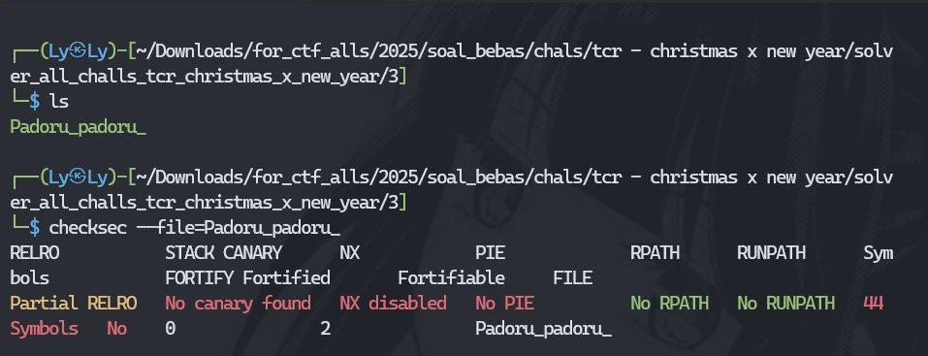
We must do this to check the protection but no PIE, it will be perfect tho. Lets use gdb (i use pwndbg)
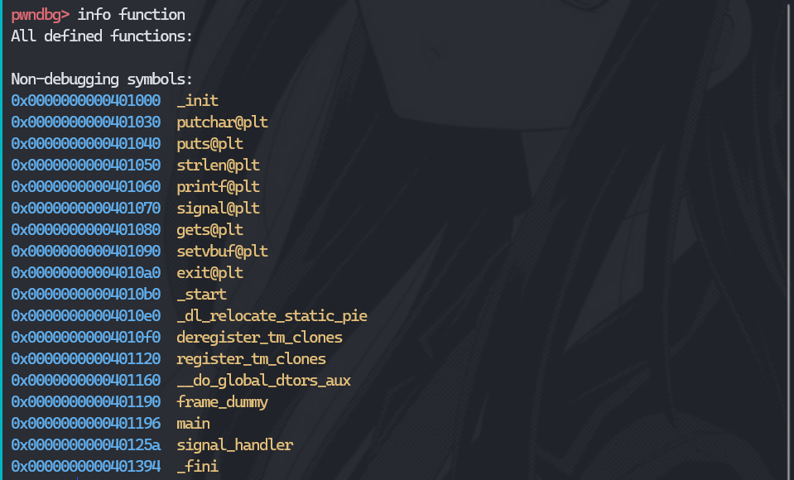
There are main and signal_handler function memory addresses. Lets disassemble it.
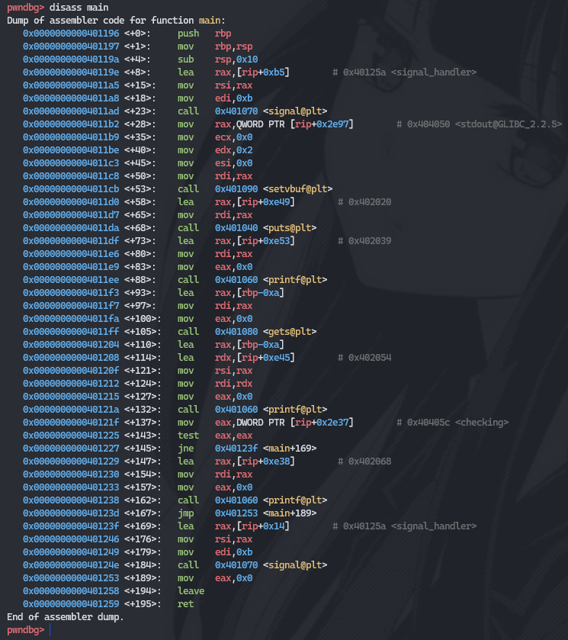
There is signal_handler, printf, and gets. Welpp, lets running to crash it.
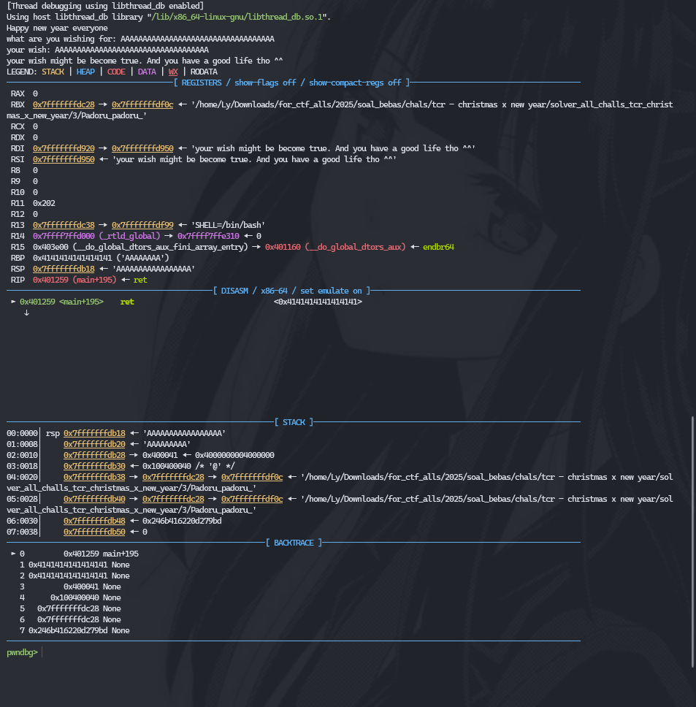
From here we know that a lot of A might crash the program. Alright then. Lets try use “cyclic 100” to get to know offset
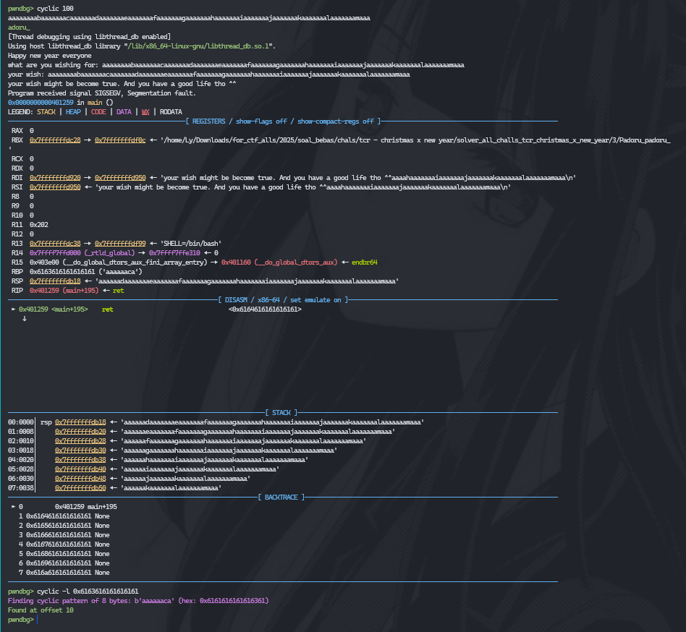
As you can see, there is crash on RBP and the offset is 10. So perfect. Welp, there are 2 ways to solve it. Using script or just run the program.
Using script:
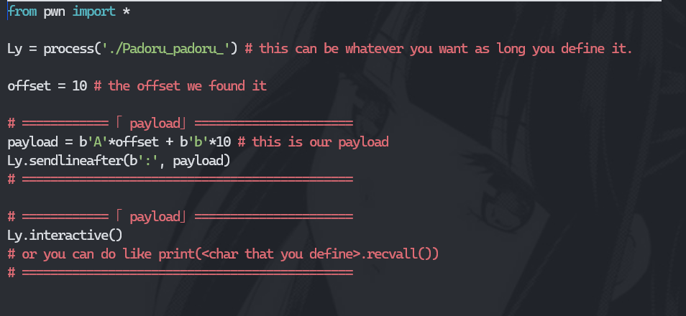
The result:
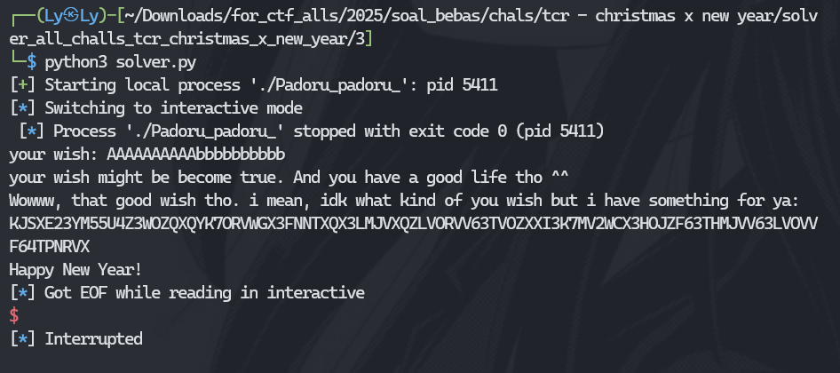
If you hit the offset without you add something, the result:
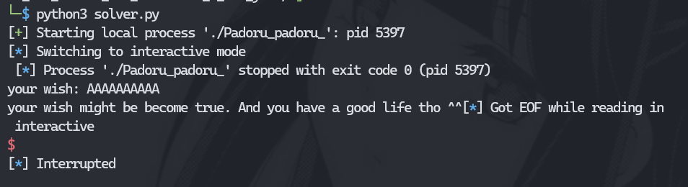

Solver 2: running it
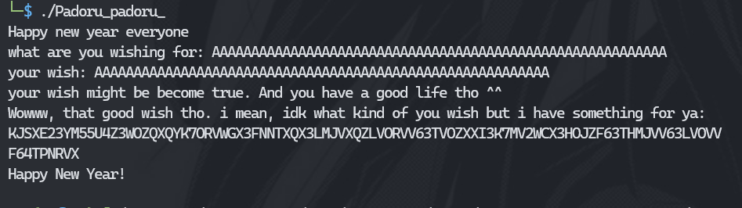
After that you can use cipher identifier to identify the encryption. Here are the identifier:
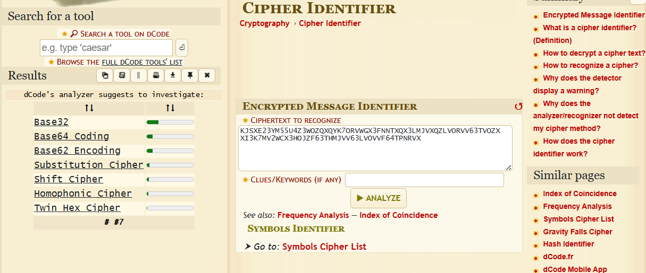
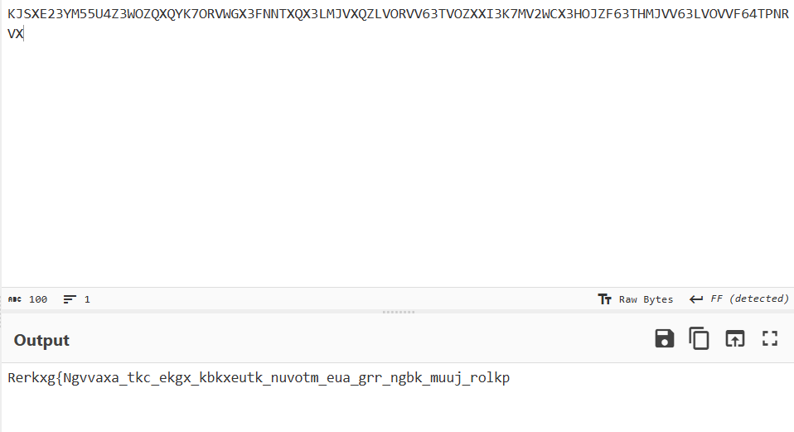
And then you can ask llm if you want (or you can use rot-13 instead)
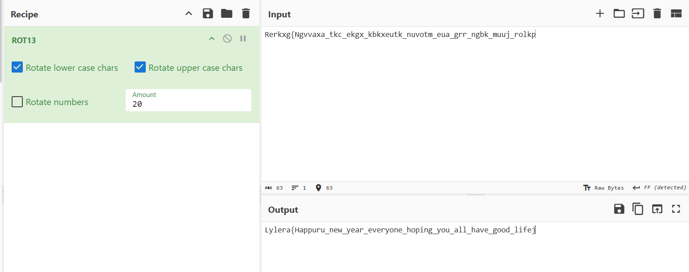

Flag: Lylera{Happuru_new_year_everyone_hoping_you_all_have_good_life}

Web exploitation - Kiesomonahoru

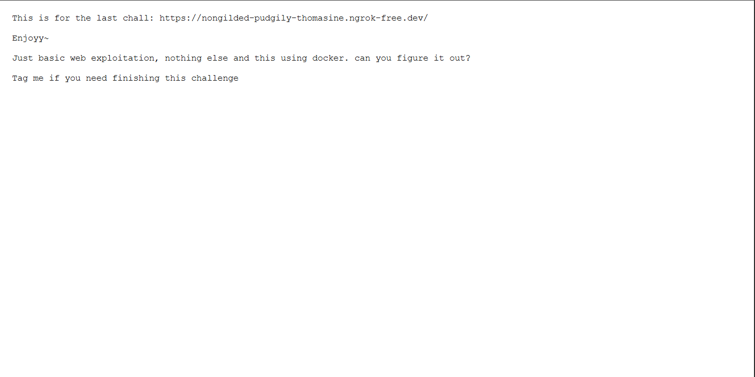
Lets go that link
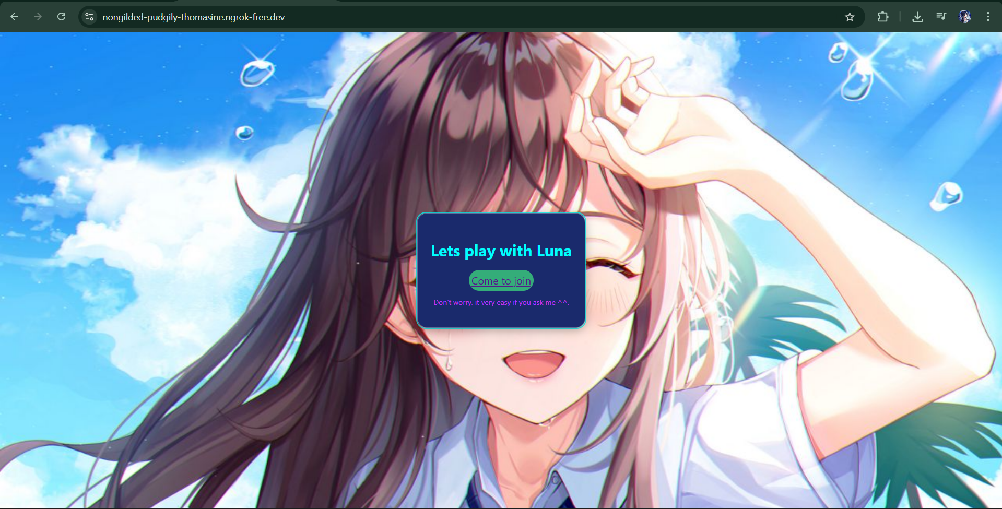
Nothing suspicious right? But lets follow the flow first.
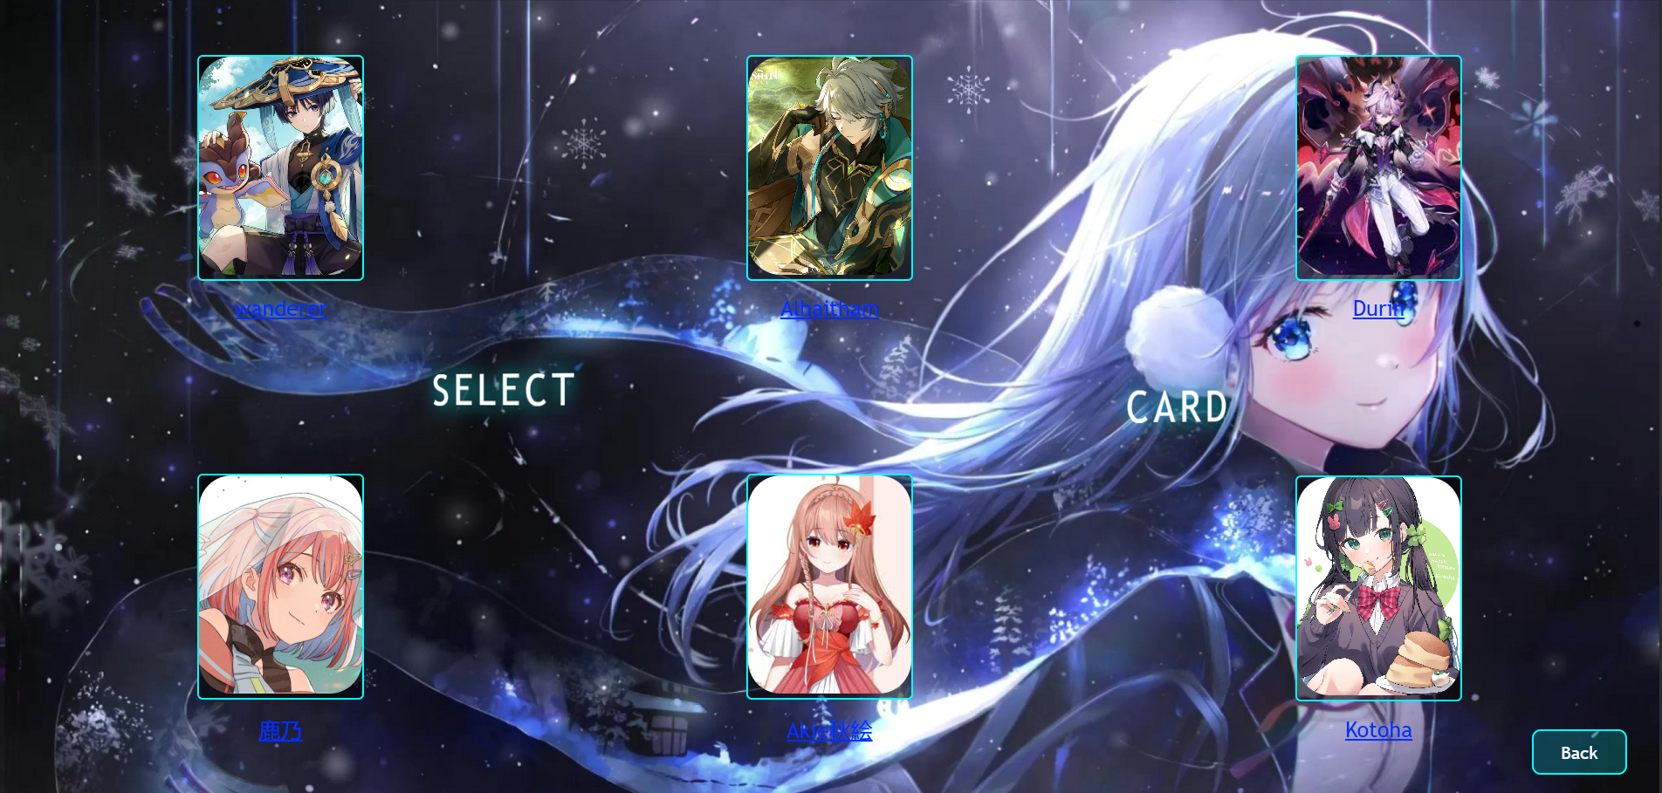
So in this chall like playing card if you might guess, lets take a look all of them
There is nothing here. Lets use some techniques that are called “robots.txt” techniques. So every website sometimes have it, so let's do it.
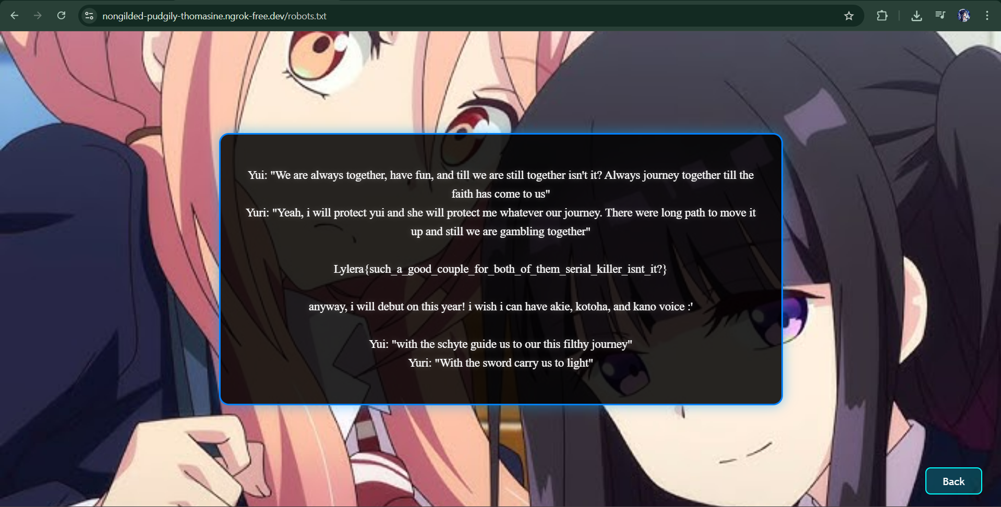
And here you go

Flag: Lylera{such_a_good_couple_for_both_of_them_serial_killer_isnt_it?}

Overall it is easy. Recommend for beginner if you ask to me ^^

Category:
- Forensic (steganography - crack zip pw - cryptography {decimal, base32, xor})
- Cryptography (binary - base64)
- Pwn / binary exploitation (buffer overflow classic and cryptography)
- Web exploitation - robots.txt

